### Task Objective

Objective of this task is to provide (and hopefully receive) constructive feedback about project pitch. After watching project pitch presentations provided by your classmates on discussion boards, provide constructive feedback for at least three other project pitch presentations. Your feedback should be in forma of a reply to the discussion board and should include the following parts:

### Project overview

Provide a Brief overview of the project and your understanding of what it is planning to do (one paragraph 100-300 words)

### Positives

Describe in detail what you liked about this project and how it was presented. Use bullet points and be concise.

### Negatives

Describe what you did not like about the pitch or the project. Provide details of how you think your classmate could improve upon the project or their presentation skills. Be constructive and try to be as helpful as possible.

For both positive and negative aspects of the pitch, you can include aspects like the level of details provided by your classmate, method of delivery, understandability of the speech and communication, application of the project, and organisation of the talk among others.

### Task Submission Details

Take screenshots of your feedback on discussion boards, put on a word document and submit to OnTrack.

### Screenshot 1

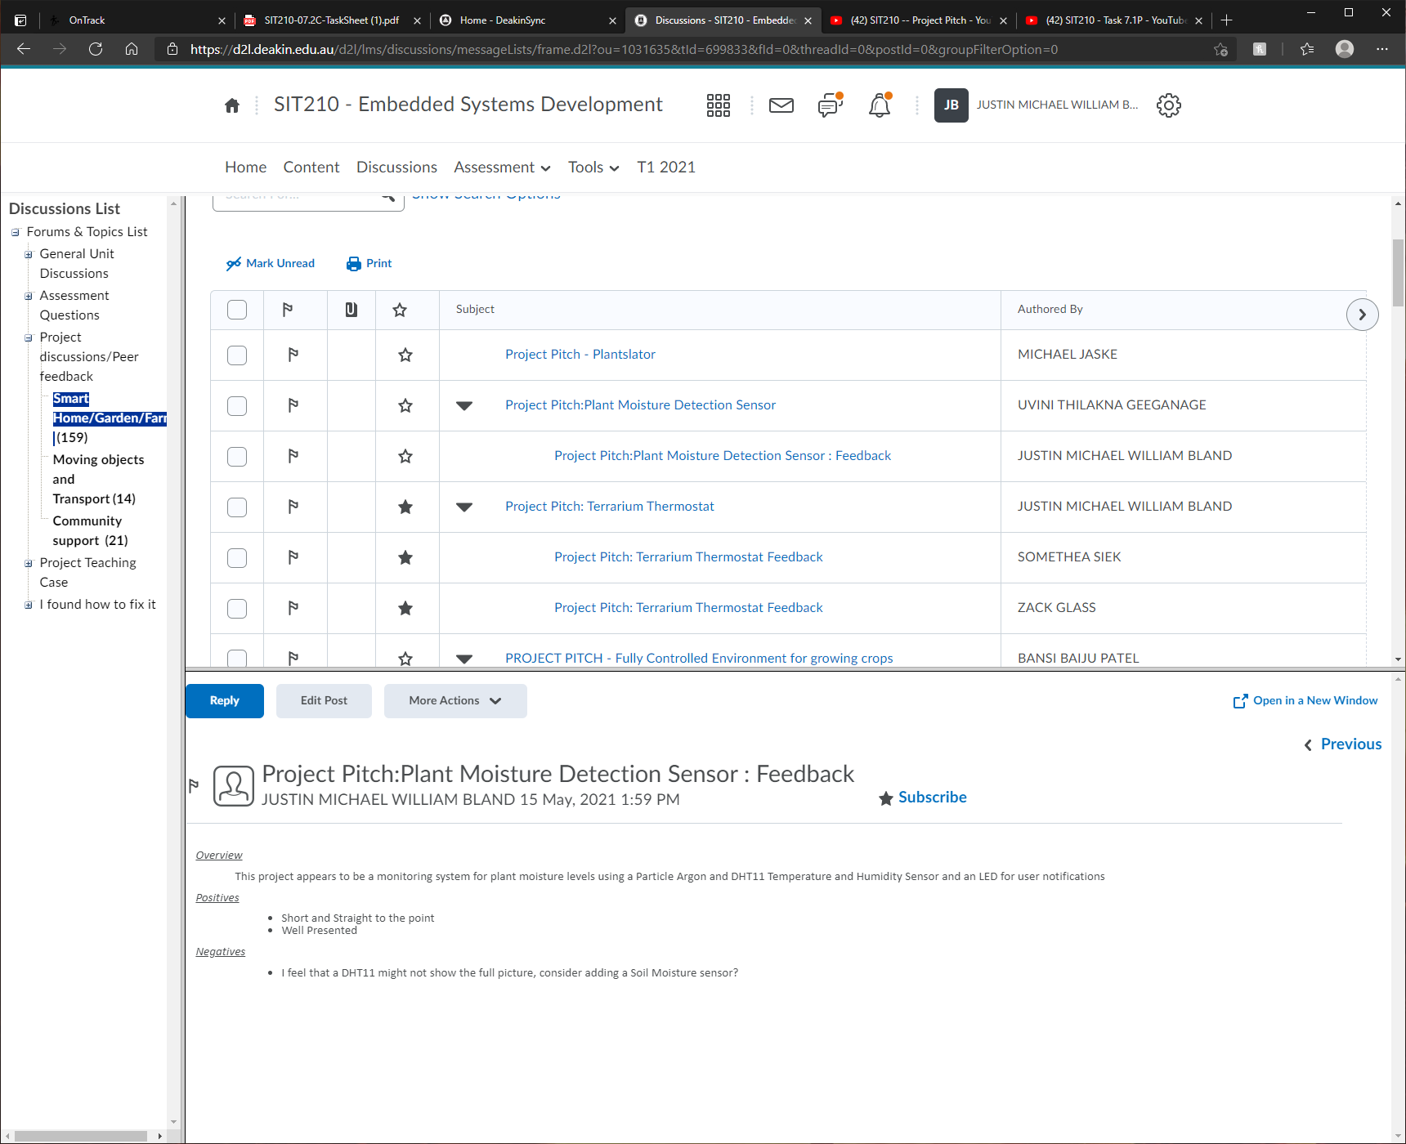

### Screenshot 2

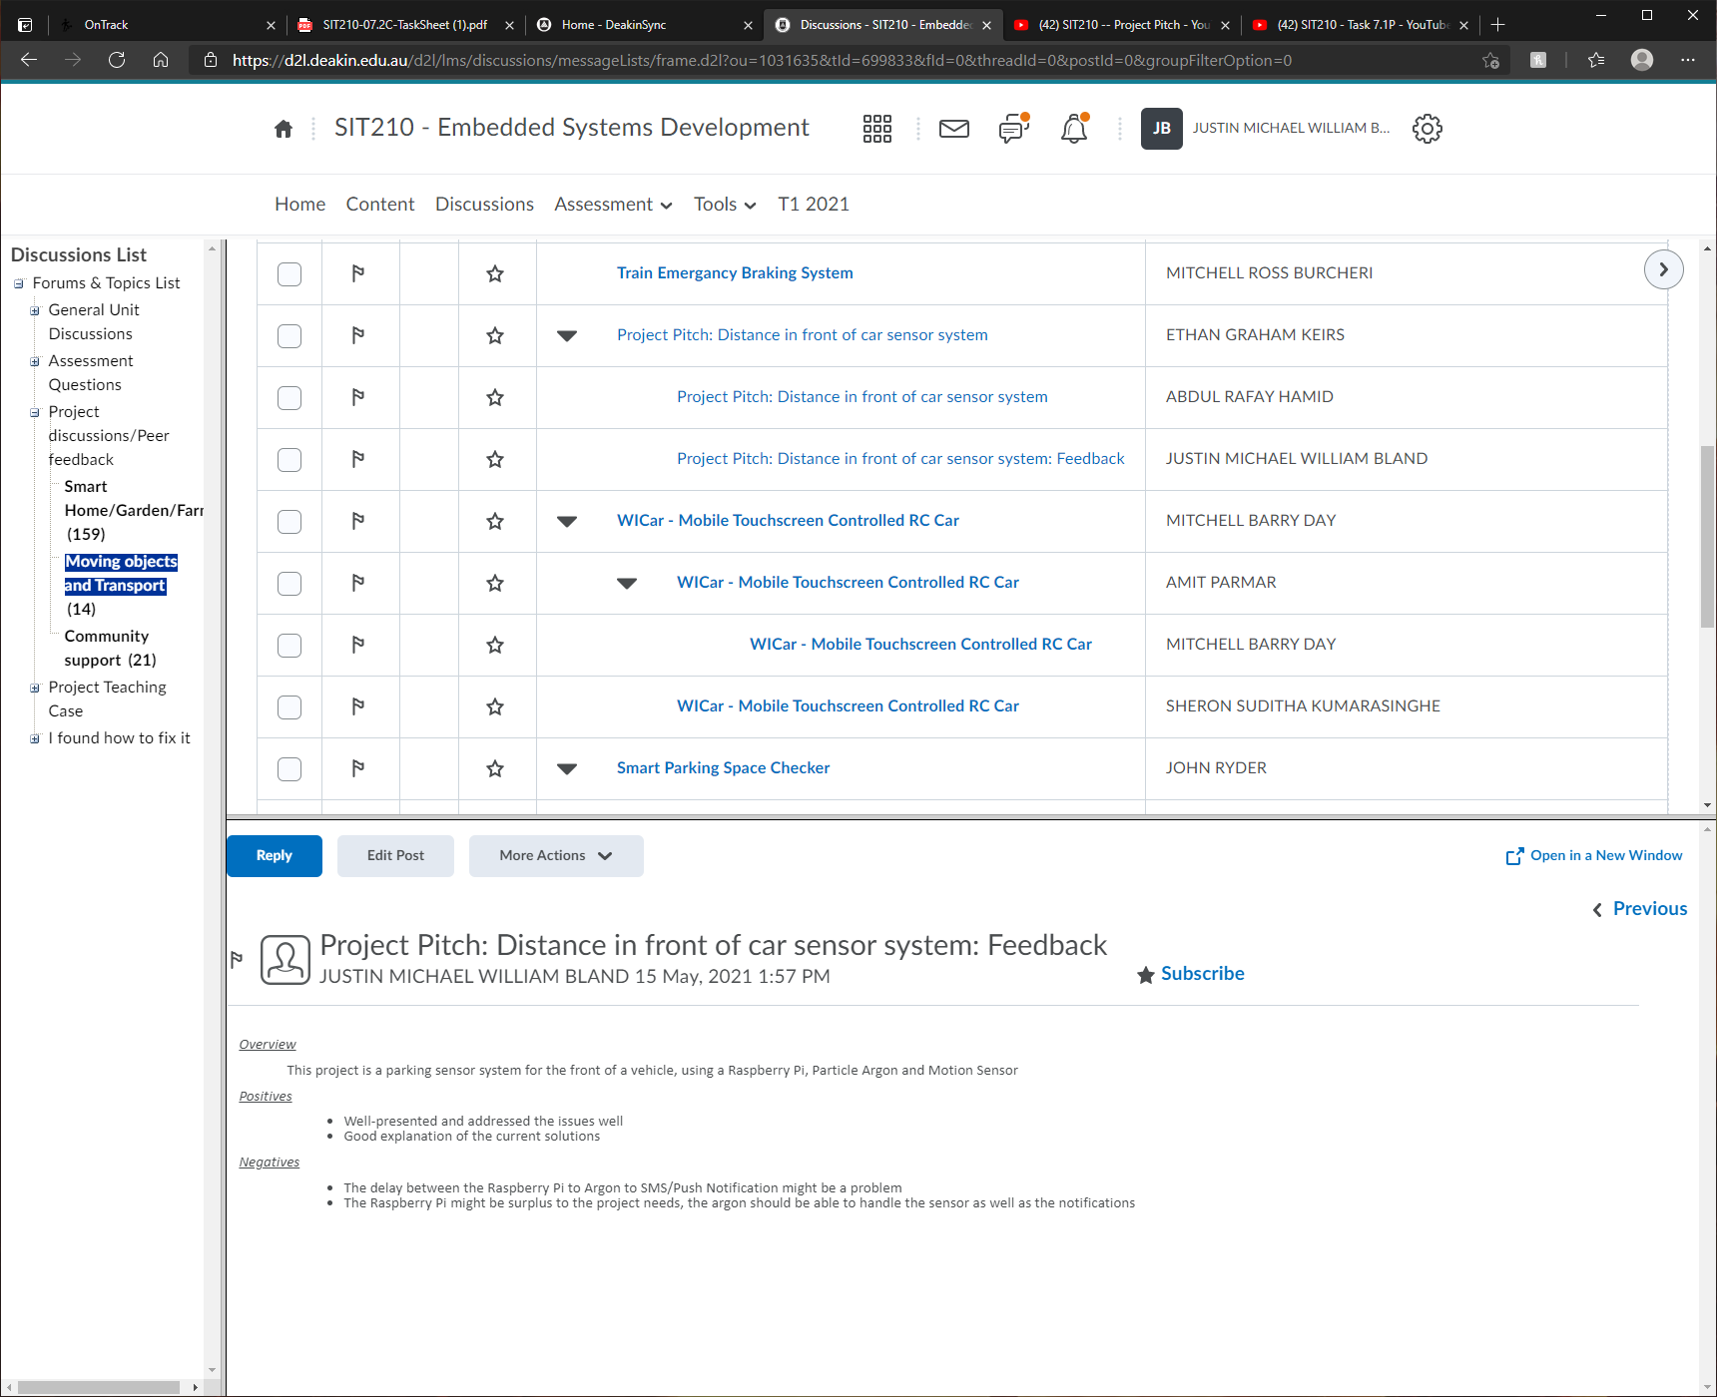

Screenshot 3

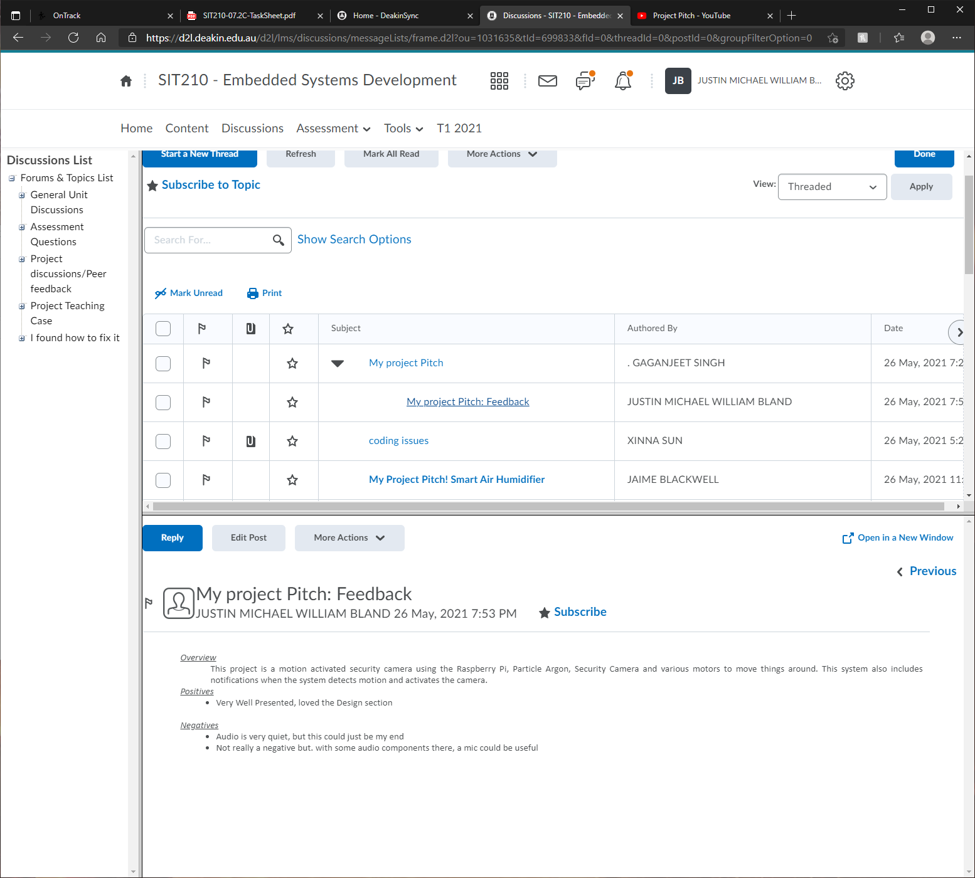

### Notes

Plant Moisture Detection Sensor: (UVINI THILAKNA GEEGANAGE)

<https://www.youtube.com/watch?v=vrc1Z5M0SdQ>

*Overview*

This project appears to be a monitoring system for plant moisture levels using a Particle Argon and DHT11 Temperature and Humidity Sensor and an LED for user notifications

*Positives*

* Short and Straight to the point
* Well Presented

*Negatives*

* I feel that a DHT11 might not show the full picture, consider adding a Soil Moisture sensor?

Distance in front of car sensor system: (ETHAN GRAHAM KEIRS)

<https://youtu.be/mppHca-jRKM>

*Overview*

This project is a parking sensor system for the front of a vehicle, using a Raspberry Pi, Particle Argon and Motion Sensor

*Positives*

* Well-presented and addressed the issues well
* Good explanation of the current solutions

*Negatives*

* The delay between the Raspberry Pi to Argon to SMS/Push Notification might be a problem
* The Raspberry Pi might be surplus to the project needs, the argon should be able to handle the sensor as well as the notifications

Smart Security Camera: (GAGANJEET SINGH)

<https://youtu.be/CBIRKaiMQoI>

*Overview*

This project is a motion activated security camera using the Raspberry Pi, Particle Argon, Security Camera and various motors to move things around. This system also includes notifications when the system detects motion and activates the camera.

*Positives*

* Very Well Presented, loved the Design section

*Negatives*

* Audio is very quiet, but this could just be my end
* Not really a negative but. with some audio components there, a mic could be useful